**EEE361**

**ASSIGNMENT**

**SET-5**

1. A wave is given is air:

E = (8ay – 6az) Sin $\left(ωt-4y-3z\right)$ V/m impinges a dielectric half- space as shown in Fig. Below. Find:

a. The incident angle $θ_{i}$

b. The reflected and Transmitted E and H field

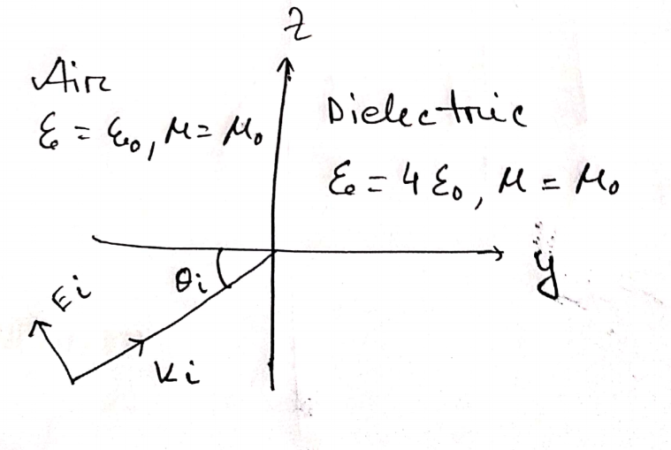

Fig: Problem 1

1. a) Explain with proper figures (in detail): In the Faraday’s electromagnetic equation (also known as Maxwell’s 3rd equation), why the sign of the time derivative is negative but the curl part (of electric field) is positive.

Also explain in detail (with proper figures): if the sign ‘were’ positive, what would happen!!!!

b) (i) calculate the divergence of this function: 25xyz + 19xy+ 30xz  
(ii) calculate the curl of this function: 25xyz + 19xy+ 30xz

(iii) Calculate the gradient of this function: 25xyz + 19xy+ 30xz

c) (i) In the primary circuit, why do we always use AC voltage source instead of DC voltage for real world applications?

(ii) Why do we use round shaped coils (I.e. Round shaped turns in the coils) in both the primary and secondary circuits [If those coils were not round shaped, what would be the problem]?

*** You should draw figures to make your explanations strong.

1. The electric and magnetic fields in free space are given below:

$$E=\frac{50}{ρ}cos\left({10}^{6}t+βz\right)a_{Ø }V/{ m}$$

$$H= \frac{H_{0}}{ρ}cos\left({10}^{6}t+βz\right){a_{ρ}}_{ }A/{ m}$$

Determine the constants Ho and β as if the fields satisfy Maxwell’s Equations. (Show detail calculation)

1. Show that

$$E_{x}(z,t) = F_{x }(t + \sqrt{με} z)$$

This expression satisfies the wave equation in a dielectric medium. Find the vector $\vec{H}$

1. If any EM field fails to satisfy Maxwell’s Equation and the wave equation derived from them, then that is said to be nonexistent or not Maxwellian. Suppose the following expressions exist in charge free-regions. Find weather they are Maxwellian or not? State why the expression/s are not Maxwellian. (Show Calculation)

$A = 40 sin (ωt + 10x) a_{z}$

$B = \frac{10}{ρ} cos (ωt - 2ρ) a_{∅}$

$C = ( 3 ρ^{2} cot ∅a_{p} + \frac{cos ∅}{ρ} a_{∅}) sin ωt$

$D = \frac{1}{r} sinθ sin(ωt - 5r) a_{∅}$